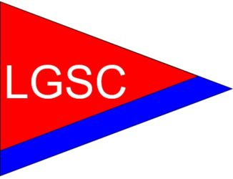

31st ANNUAL
GUNTERSVILLE CUP REGATTA

Lake Guntersville - April 22 and 23, 2022
Hosted by Lake Guntersville Sailing Club

For those attending but not racing please RSVP

The Lake Guntersville Sailing Club (LGSC) is pleased to invite you to participate in the 31thAnnual Guntersville Cup Regatta to be held out of the Lake Guntersville Marina, home of the Lake Guntersville Sailing Club at 21500 U.S. Hwy. 431, Guntersville, Alabama 35976 LGSC is located just North of Guntersville on beautiful Lake Guntersville. This is a two-day, two race Regatta.

Schedule of Events:
Friday, April 22, 2022
1700 Social Hour
1800 Italian Dinner (RSVP) LGSC Club House
1830 Final Registration LGSC Club House
1900 Skippers Meeting LGSC Club House
Saturday, April 23, 2022
0730 Continental Breakfast (Racers) LGSC Club House
0955 Warning Signal 1st Race Lake Guntersville
1000 Starting Signal 1st Race Lake Guntersville
ASAP* Warning Signal 2nd Race Lake Guntersville
ASAP + 5 min Starting Signal 2nd Race Lake Guntersville
1700 Social Hour LGSC Club House
1800 Barbeque Dinner (RSVP) LGSC Club House
1900 Awards LGSC Club House
1930 Live Music at the Pavilion LGSC Club House

Friday Night Social & Italian Dinner @ $10.00/each No:___ Amt: $______

Saturday Continental Breakfast No:___ Amt: $______

Saturday Night Social & BBQ Dinner @ $16:00/ea) No:___ Amt: $______

Total Amount enclosed: $______ Check No. ___________

*ASAP - As soon as possible after the preceding race

